How to identify if your lock has AMI incentives

On your lock form, the first notation under Notes/Advisories (in red) will always tell you what the AMI is in your county, and what percentage you fall in to.
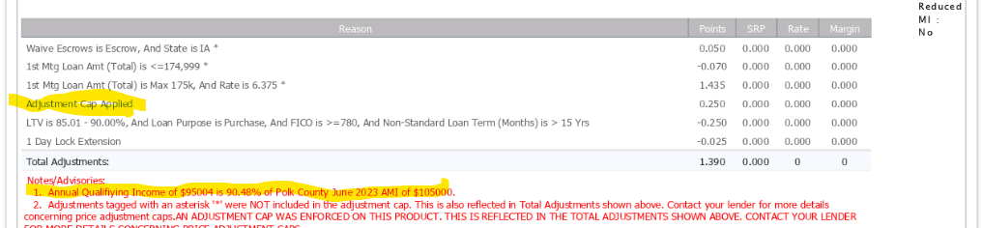
Also, under Adjustments look for words like Adjustment Cap Applied (or anything to do with AMI)

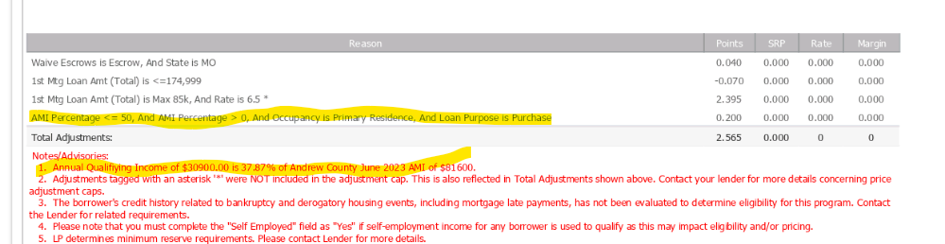

Within Encompass, to make sure that you have not unintentionally locked a loan with AMI incentives, look at Forms - Borrower Summary (GM3). It will indicate that it is an AMI loan. It is suggested that you add this field to any pipeline views in which you monitor your locked loans.
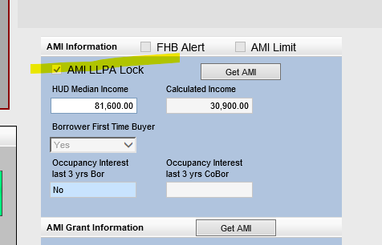

As of 4/2/2024 the current Fannie Mae LLPAs for are listed below

https://singlefamily.fanniemae.com/media/9391/display

